**EDUCATIONAL WEBSITE ( LearnEd )**

Front End Development (Board Infinity)

A Project Report

Submitted in partial fulfilment of the requirements for the award of degree of

Bachelors in Computer Science & Technology

Submitted to

LOVELY PROFESSIONAL UNIVERSITY

# PHAGWARA, PUNJAB



(June – July , 2021)

Submitted By –

Name : Yash Goel

Registration Number : 11904382



Student’s Signature :

**STUDENT DECLARATION**

# To whom so ever it may concern

I, Yash Goel , 11904382 , hereby declare that the work done by me on the topic “ Educational Website “ from June, 2021 to July, 2021 is a record of

original work for the partial fulfilment of the requirements for the award of the degree , Bachelor in Computer Science & Engineering.

Yash Goel

( 11904382 )

Dated : 5 August , 2021

**Certificate from Board Infinity**

**Course :** Front End Development

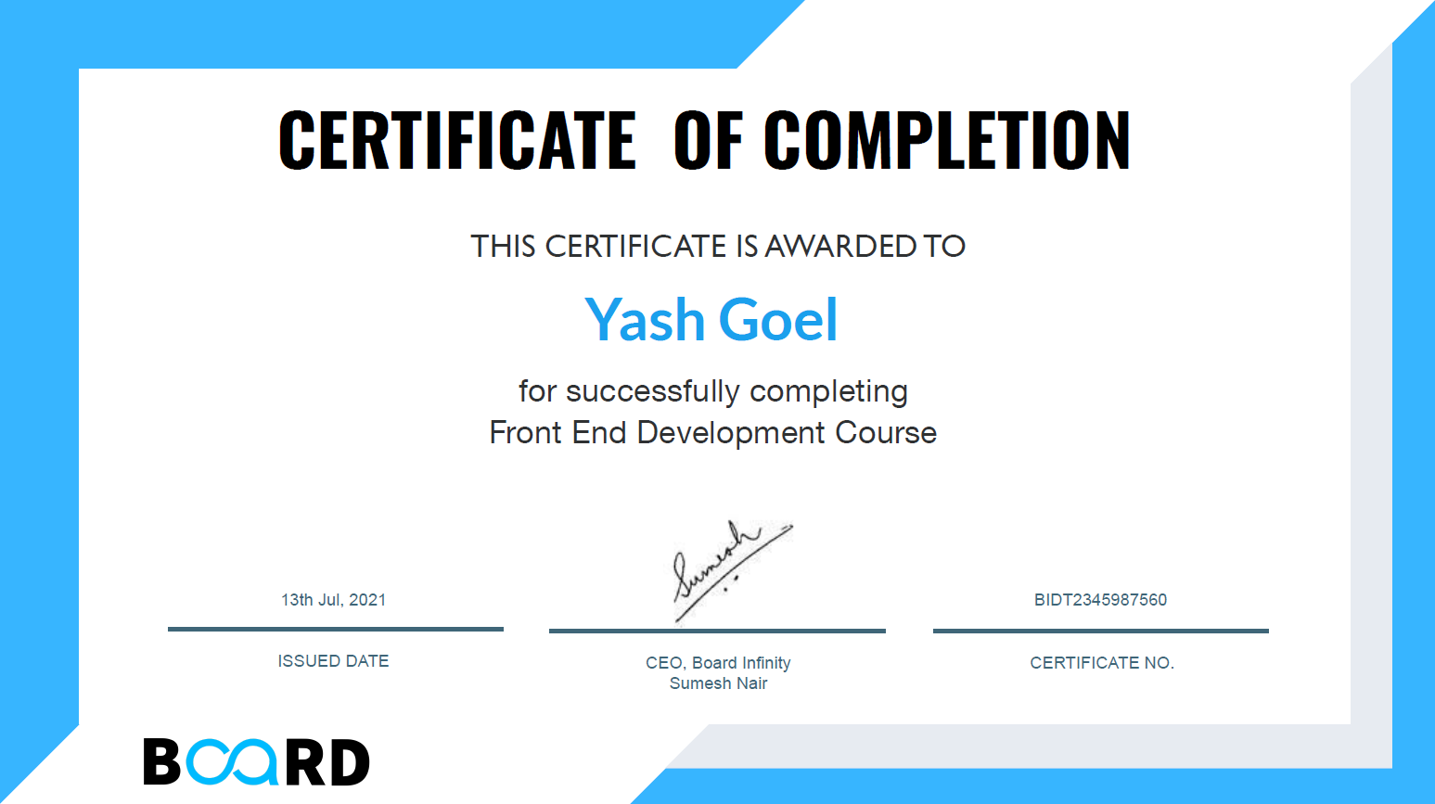

# **ACKNOWLEDGEMENT**

Primarily , I would thank God for being able to complete this project with successs. But it won’t be a successful without the kind support from Board Infinity , where I have pursued this course in summer vacation. I was able to take this course at very less cost , just because of our university program . So, a very special thanks to my university , LPU.

I would like to express my gratitude to all the humble and well experienced teachers of Board Infinity, and a special thanks to my course teacher Nand Kishore Sir . Because of their brilliant teaching I was able to complete the Project (on the topic Educational Website) in a very healthy manner.

# **TABLE OF CONTENTS**

TITLE PAGE No.

1. Chapter 1 : Introduction 06
2. Chapter 2 : Technology Learnt 08
3. Chapter 3 : Design 10
4. Chapter 4 : Flow Chart 12
5. Chapter 5 : Implementation 13
6. Chapter 6 : Link with other pages 21
7. Chapter 6.1 : Login / Register Page 21
8. Chapter 6.2 : Computer Science Page 23
9. Chapter 6.3 : JEE Page 26
10. Chapter 6.4 : GATE Page 29
11. Chapter 7 : Technology and Framework Used 31
12. References 32

**Chapter 1 INTRODUCTION**

**LearnEd**

“Education is the passport to the future, for tomorrow belongs to those who prepare for it today.” “Your attitude, not your aptitude, will determine your altitude.” “If you think education is expensive, try ignorance.” “The only person who is educated is the one who has learned how to learn …and change.”



**Objective :**

In Today’s time , any person can learn any course or skill online for free . There is no hindrance in his path . A person can see videos on Youtube for learning thimgs. Making use of Youtube for learning things , is a great option . But there is also problem in that. A lot of content is available on youtube , and that too in an unorganized manner.

For a same course or skill , there are hundread’s of videos , and that too of many teachers. For a student , it becomes too hectic , to choose the best teacher and the best lecture. Sometimes it also becomes difficult to find all the lectures in an organized manner for a particular topic or subject.

Here , LearnEd plays the role . My main objective behind this website , is to put all the good lectures on youtube in an organized manner , for every subject , course and exam . So that , any person can find his relevant topic easily and that too by the best teacher.

**Chapter 2 Technology Learnt**

* **HTML :** The HyperText Markup Language, or HTML is the standard [markup language](https://en.wikipedia.org/wiki/Markup_language) for documents designed to be displayed in a [web browser](https://en.wikipedia.org/wiki/Web_browser). It can be assisted by technologies such as [Cascading Style Sheets](https://en.wikipedia.org/wiki/Cascading_Style_Sheets) (CSS) and [scripting languages](https://en.wikipedia.org/wiki/Scripting_language) such as [JavaScript](https://en.wikipedia.org/wiki/JavaScript).  
  [Web browsers](https://en.wikipedia.org/wiki/Web_browser) receive HTML documents from a [web server](https://en.wikipedia.org/wiki/Web_server) or from local storage and [render](https://en.wikipedia.org/wiki/Browser_engine) the documents into multimedia web pages. HTML describes the structure of a [web page](https://en.wikipedia.org/wiki/Web_page) [semantically](https://en.wikipedia.org/wiki/Semantic_Web) and originally included cues for the appearance of the document.
* **CSS :** Cascading Style Sheets (CSS) is a [style sheet language](https://en.wikipedia.org/wiki/Style_sheet_language) used for describing the [presentation](https://en.wikipedia.org/wiki/Presentation_semantics) of a document written in a [markup language](https://en.wikipedia.org/wiki/Markup_language) such as [HTML](https://en.wikipedia.org/wiki/HTML). CSS is a cornerstone technology of the [World Wide Web](https://en.wikipedia.org/wiki/World_Wide_Web), alongside HTML and [JavaScript](https://en.wikipedia.org/wiki/JavaScript).  
  CSS is designed to enable the separation of presentation and content, including [layout](https://en.wikipedia.org/wiki/Page_layout), [colors](https://en.wikipedia.org/wiki/Color), and [fonts](https://en.wikipedia.org/wiki/Typeface). This separation can improve content [accessibility](https://en.wikipedia.org/wiki/Accessibility), provide more flexibility and control in the specification of presentation characteristics, enable multiple [web pages](https://en.wikipedia.org/wiki/Web_page) to share formatting by specifying the relevant CSS in a separate .css file which reduces complexity and repetition in the structural content as well as enabling the .css file to be [cached](https://en.wikipedia.org/wiki/Cache_(computing)) to improve the page load speed between the pages that share the file and its formatting.
* **JavaScript :** JavaScript , often abbreviated as JS, is a [programming language](https://en.wikipedia.org/wiki/Programming_language) that conforms to the [ECMAScript](https://en.wikipedia.org/wiki/ECMAScript) specification. JavaScript is [high-level](https://en.wikipedia.org/wiki/High-level_programming_language), often [just-in-time compiled](https://en.wikipedia.org/wiki/Just-in-time_compilation), and [multi-paradigm](https://en.wikipedia.org/wiki/Programming_paradigm). It has [curly-bracket syntax](https://en.wikipedia.org/wiki/List_of_programming_languages_by_type#Curly-bracket_languages), [dynamic typing](https://en.wikipedia.org/wiki/Dynamic_typing), [prototype-based](https://en.wikipedia.org/wiki/Prototype-based_programming) [object-orientation](https://en.wikipedia.org/wiki/Object-oriented_programming), and [first-class functions](https://en.wikipedia.org/wiki/First-class_function).   
  Alongside [HTML](https://en.wikipedia.org/wiki/HTML) and [CSS](https://en.wikipedia.org/wiki/CSS), JavaScript is one of the core technologies of the [World Wide Web](https://en.wikipedia.org/wiki/World_Wide_Web). Over 97% of [websites](https://en.wikipedia.org/wiki/Website) use it [client-side](https://en.wikipedia.org/wiki/Client-side) for [web page](https://en.wikipedia.org/wiki/Web_page) behavior, often incorporating third-party [libraries](https://en.wikipedia.org/wiki/Library_(computing)). Most [web browsers](https://en.wikipedia.org/wiki/Web_browser) have a dedicated [JavaScript engine](https://en.wikipedia.org/wiki/JavaScript_engine) to execute the code on the [user](https://en.wikipedia.org/wiki/User_(computing))'s device.   
  As a multi-paradigm language, JavaScript supports [event-driven](https://en.wikipedia.org/wiki/Event-driven_programming), [functional](https://en.wikipedia.org/wiki/Functional_programming), and [imperative](https://en.wikipedia.org/wiki/Imperative_programming) [programming styles](https://en.wikipedia.org/wiki/Programming_paradigm). It has [application programming interfaces](https://en.wikipedia.org/wiki/Application_programming_interface) (APIs) for working with text, dates, [regular expressions](https://en.wikipedia.org/wiki/Regular_expression), standard [data structures](https://en.wikipedia.org/wiki/Data_structure), and the [Document Object Model](https://en.wikipedia.org/wiki/Document_Object_Model) (DOM).

**Chapter 3** **DESIGN**

**Module Wise Description**

* **Home-Page (Landing Page) :**

This is the main page of the site . This page contains all the features and services of the site. At first it has a search box , which will be used by the user to search for the topic , user is interested in . It contains a navigation bar consisting of different nav-bars like about , portfolio , services , about us and login . This home page contains different modules , which can be used by the user .

* **Login / Register Page :**

This is the page that will be opened when the user clicks on the login nav-bar in navigation bar list. A new user can register here by his email , or can direct login .

A person can also direct login by clicking on sign in with Google . After signing in , user will be redirected to the home page.

* **About Us Module :**

This module gives some information about the site and also tells the moto of the site.

* **Portfolio Module :**

In this module , the first division tells about the moto of the site .

Second division gives information about four things . It tells about how many students have enrolled on our site , how many are placed . Also tells that how many courses are available on our site and how many total projects are there .

* **Services Module :**

In this module a user can see all the services provided by the site . It includes Computer courses , Building concepts for competitive exams , online video lectures ,Sample papers of various competitive exams , performance and ranking report , discussion with the tutors and mentors , brain teasing questions to improve IQ and 24x7 Online Support.

* **Contact Us Module :**

This module is built for user-convenience and to help them with every aspect of the website. User can fetch information and assistance related to the website through this help-desk.

* **Feedback Module :**

This module would take the feedback from the users regarding the overall management and effective functioning of the website after taking mandatory inputs from the user-end.

**Chapter 4 FLOW CHART**

**Chapter 5 IMPLEMENTATION**

The first page of any website is the Landing Page. As the user opens the website, the Home Page creates the first impression.



This module of website consists of a logo on the left hand side , on every page of the site . When a user clicks on this logo , he gets redirected to this home page .

This module also contains following navigation bars : ABOUT , PORTFOLIO , SERVICES , CONTACT US , LOGIN PAGE and SEARCH BAR .



This is the logo of the site.

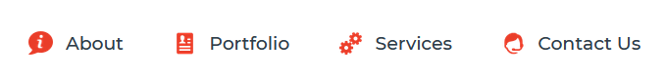

This is the Navigation Bar.

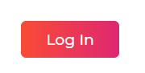

This is the Button for Login / Register Page



This is a Search Box , for searching anything in the site.

A Search Box is also provided on the banner of the main page .



Next Comes the Subjects list . Each subject redirects to a new page which contains the information about the subject.

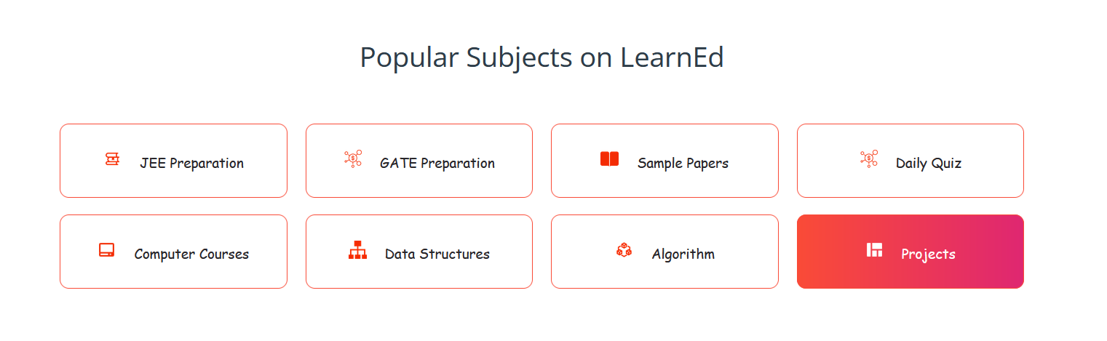

A hover effect is also provided on each box.

Code for the hover effect.

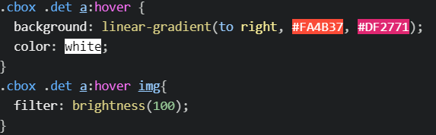

Then Comes the about section , which tells about the site .



A shadow effect is provided is side text.

Code for the shadow effect.

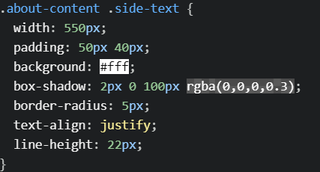

**Portfolio :**

This Section tells about the enrolled student count , number of courses available , number of placed students and the total projects available.



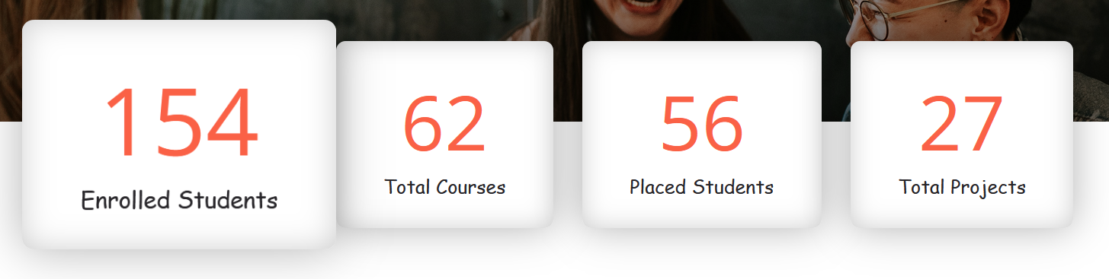

A hover effect is given here.

Code for which is.

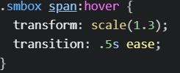

**Services :**

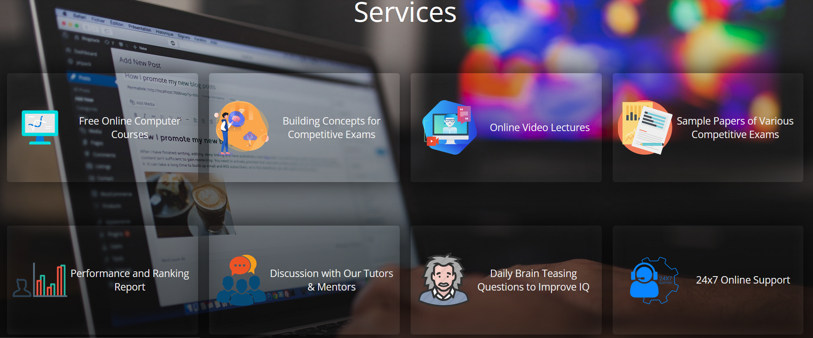

From this section a user will be redirected to different pages and modules of the site .

Here all the services that are provided by the site are listed.



A hover and a shadow effect is given here.

**Contact us :**

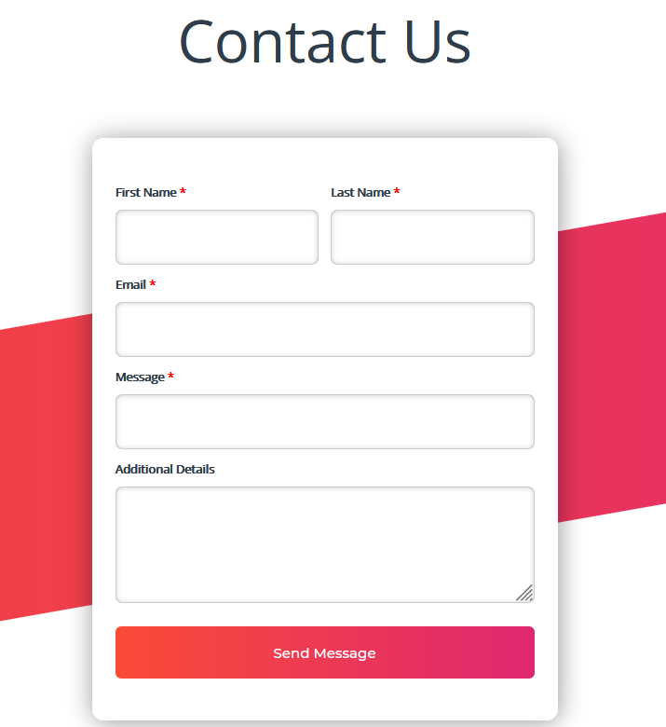

This is a contact us module where user can interact with us directly , by filling some necessary information .

**Feedback Module :**

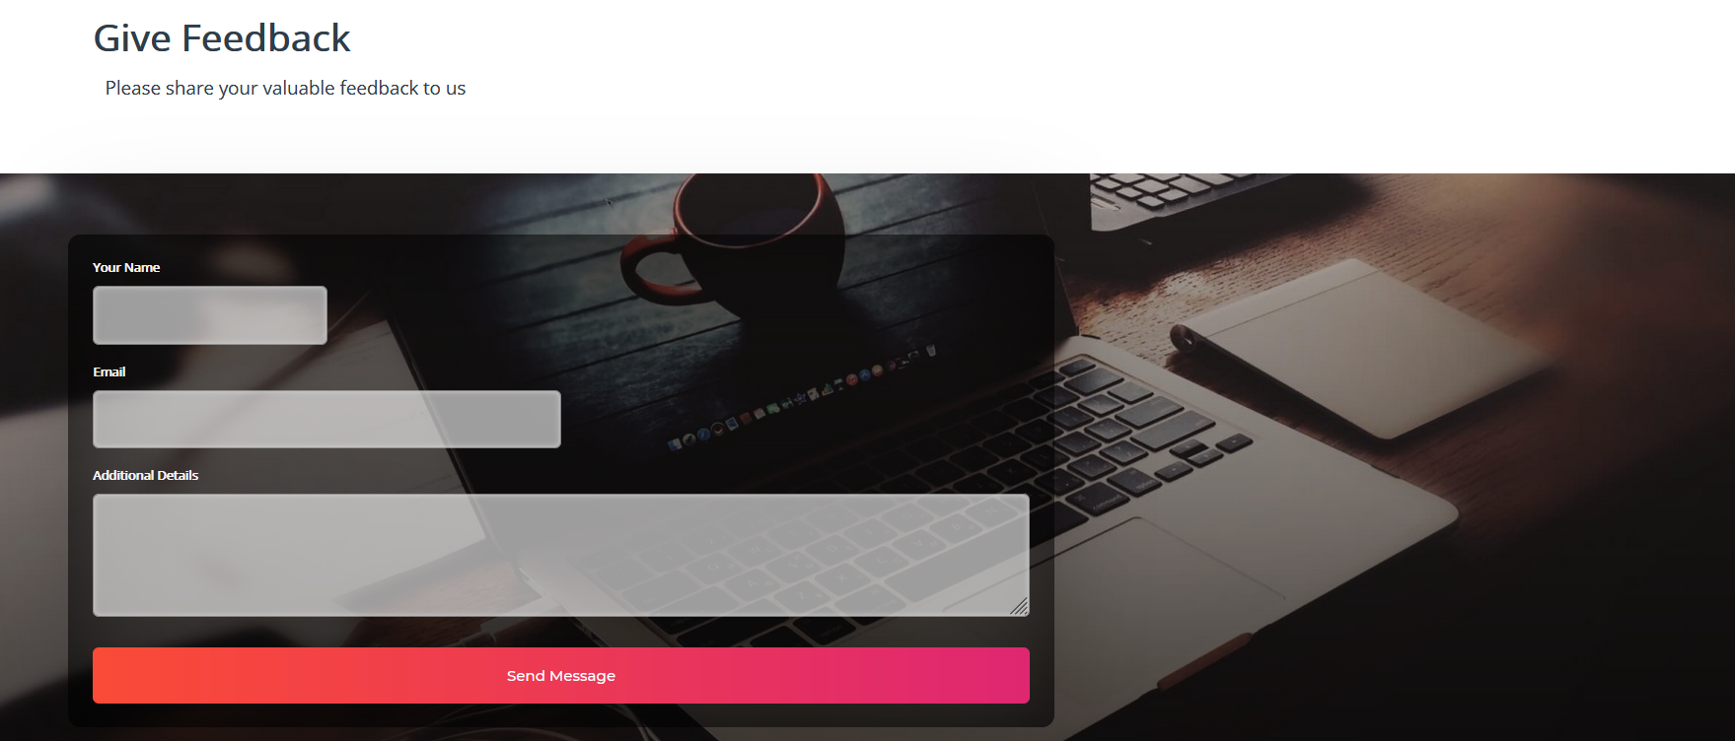

The feedback page asks the user to enter their valuable feedback about their experiences with the webpage and suggest any other changes and satisfactory modifications. This is an optional field and the response entered by the user is recorded.



This is a scrolling text at the bottom of the site.

Code for this is.

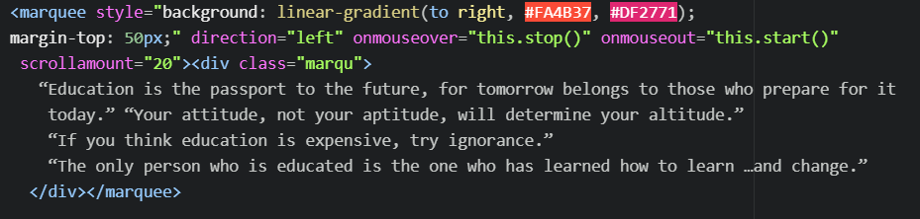



A newsletter option is provided at the end , which the user can subscribe

by entering his email id .

**Chapter 6 LINKS WITH OTHER PAGES**

**6.1 Login / Register page :**



This will redirect the user from home page to login page.

**Login Division :**

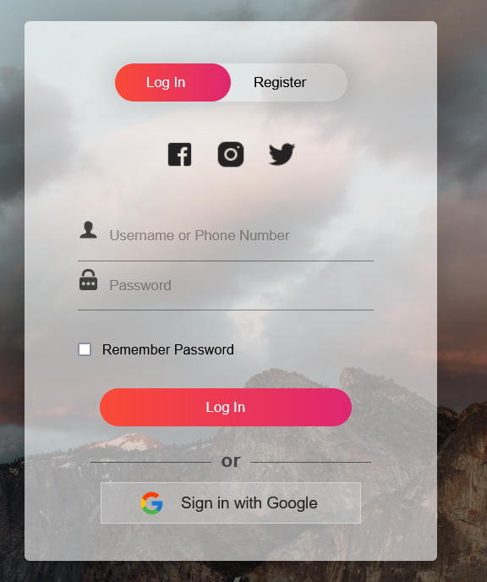

**Register Division :**

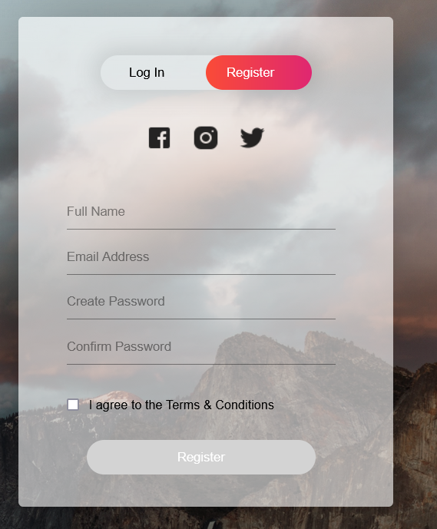

* Both login and register divisions are designed by CSS and linked with Home page.
* Basic JavaScript is used for smooth division scrolling.

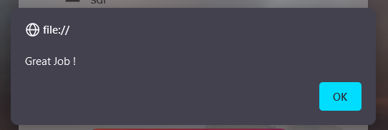

A dialog box appears after clicking on submit.

When user clicks on OK , he gets redirect to the Home page.

**6.2 COMPUTER SCIENCE PAGE**

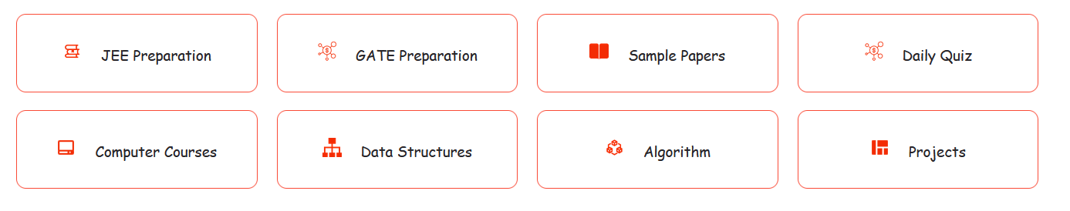

This will redirect the home page to Computer Science page.





Navigation bar that redirects to other pages / modules of the site.

This page contains videos that are embeded from youtube.

Here all the lectures are divided in an organized manner , under their respective topic.

Lectures are from the best teachers on youtube.

A user can watch those lectures on this site , or can just go to youtube directly with the link of the lecture provided.

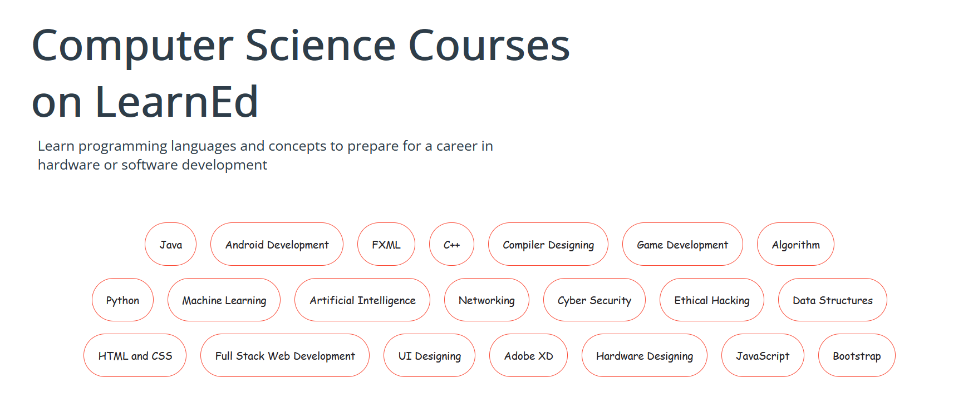

This division contains all the major topics related to Computer Science.

A user can click on any of the topic , and will be redirected to their respective material and lectures.

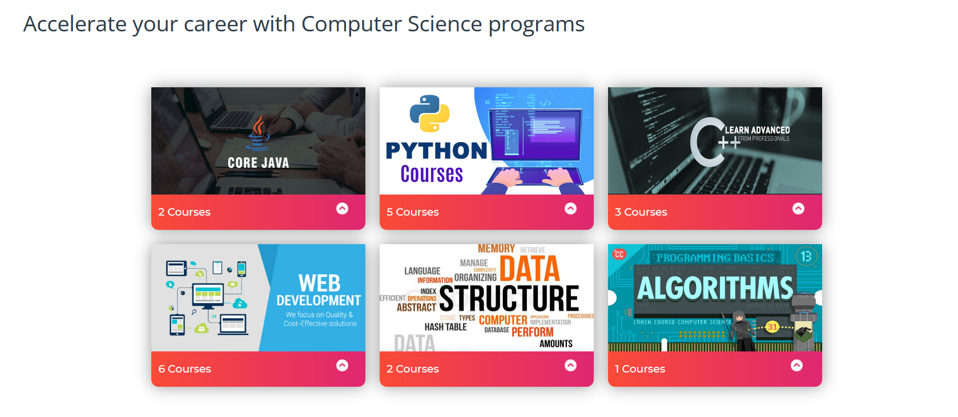

All courses are divided into categories . After clicking on these categories , user gets redirected to that module.

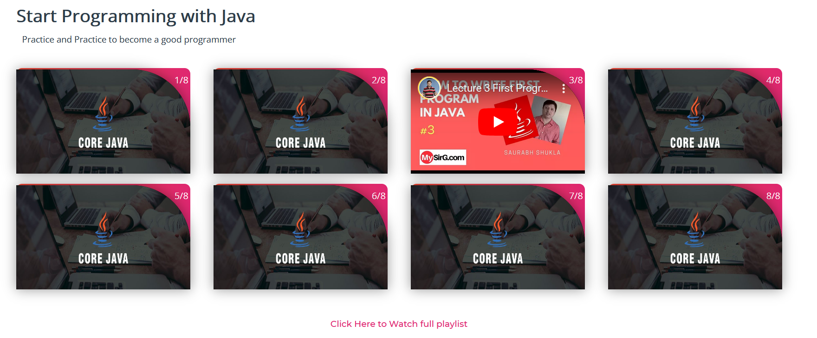

Here videos are embedded , in an organized manner .

User can watch these videos , here on the site only . Or can visit the original page.

Full playlist link is also given at the bottom of the topic.

**6.3 JEE PAGE**



This will redirect the home page to JEE page.





Navigation bar that redirects to other pages / modules of the site.

This page contains videos that are embeded from youtube.

Here all the lectures are divided in an organized manner , under their respective topic.

Lectures are from the best teachers on youtube.

A user can watch those lectures on this site , or can just go to youtube directly with the link of the lecture provided.

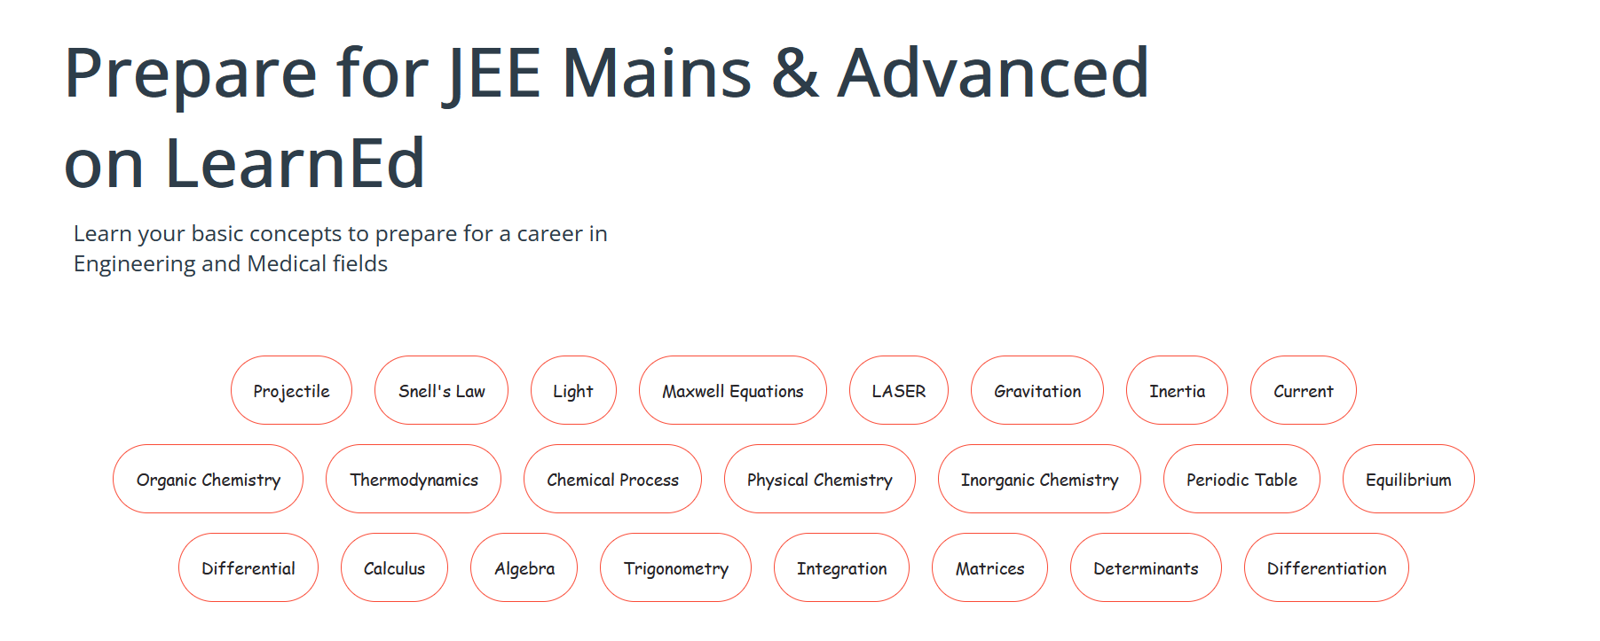

This division contains all the major topics related to JEE .

A user can click on any of the topic , and will be redirected to their respective material and lectures.

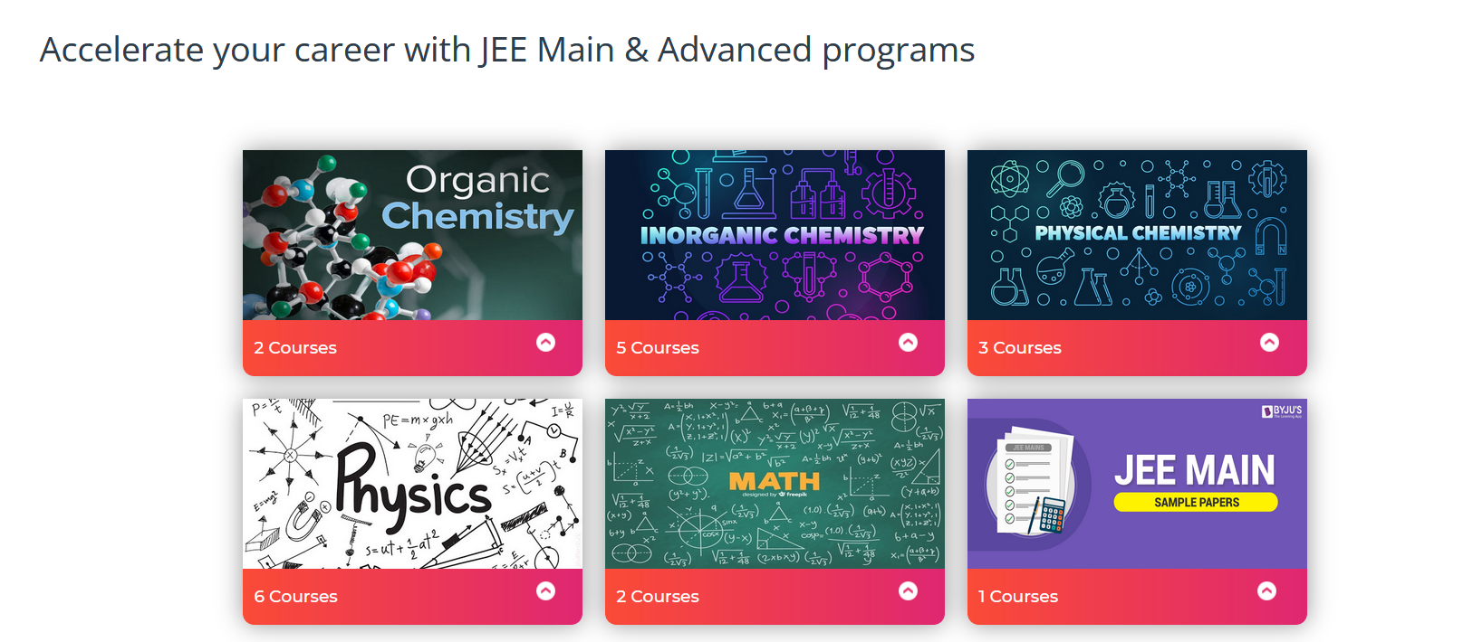

All courses are divided into categories . After clicking on these categories , user gets redirected to that module.

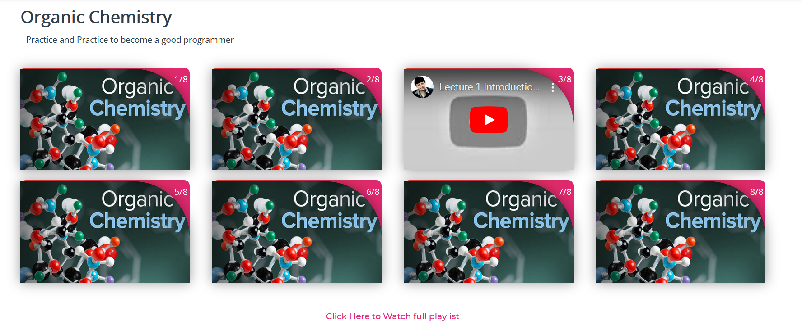

Here videos are embedded , in an organized manner .

User can watch these videos , here on the site only . Or can visit the original page.

Full playlist link is also given at the bottom of the topic.

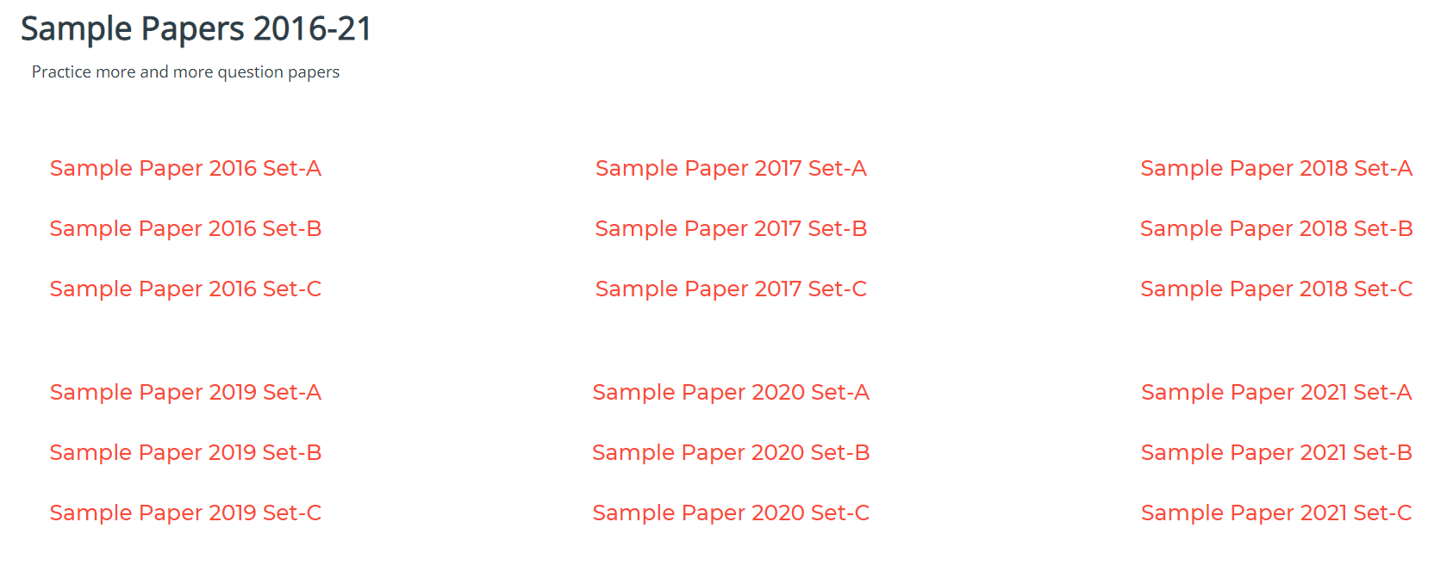

Sample papers are also given , which can be downloaded in pdf format.

**6.4 GATE PAGE**



This will redirect the home page to GATE page.



Navigation bar that redirects to other pages / modules of the site.

This page contains videos that are embeded from youtube.

Here all the lectures are divided in an organized manner , under their respective topic.

Lectures are from the best teachers on youtube.

A user can watch those lectures on this site , or can just go to youtube directly with the link of the lecture provided.

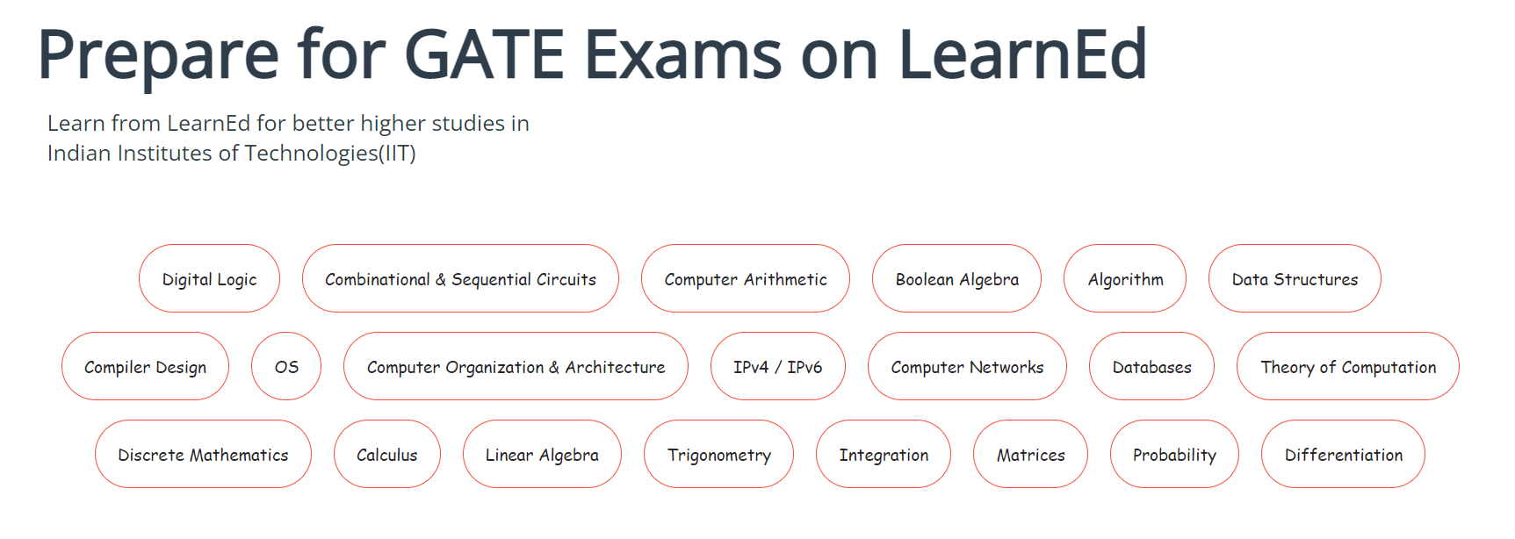

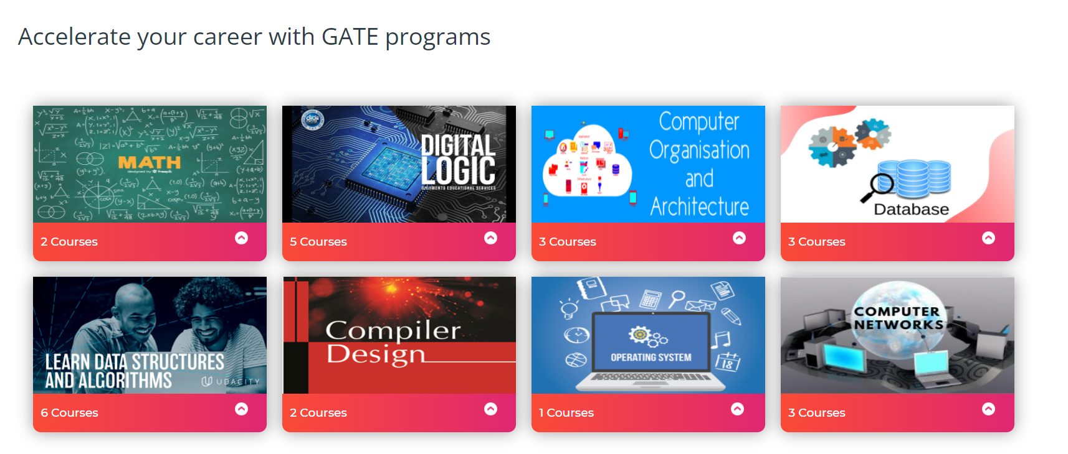

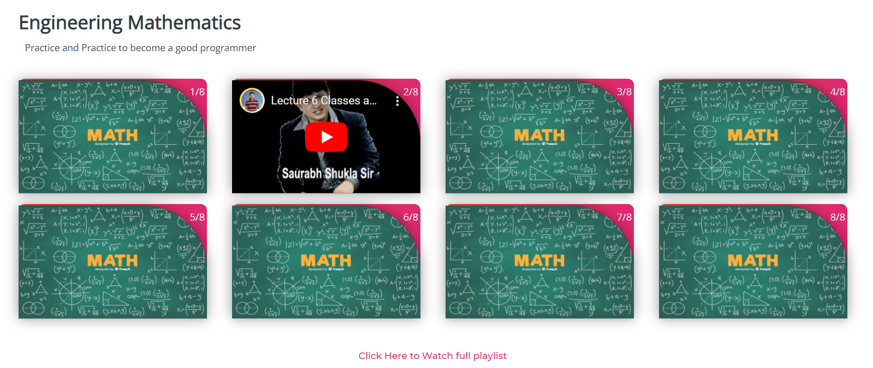

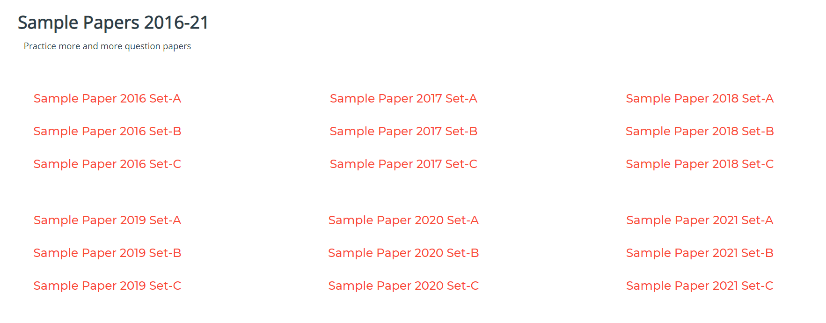

**Chapter 7 Technology and Framework Used**

We used the Text-Editor Tool **“ATOM”** for coding purpose.

We used the concepts of-

* • HTML
* • CSS
* • JAVASCRIPT

For designing our webpages and validating the data entries.

We downloaded the pictures and videos from Internet, for the successful completion of the project.

The website is compatible to run on all the browsers. But in our project we have worked with **“Google Chrome”** browser.

**References**

1. [Stack Overflow - Where Developers Learn, Share, & Build Careers](https://stackoverflow.com/)
2. [CSS-Tricks](https://css-tricks.com/)
3. [HTML Tutorial (w3schools.com)](https://www.w3schools.com/html/)
4. [The Modern JavaScript Tutorial](https://javascript.info/)
5. [YouTube](https://www.youtube.com/)